**Assignment - 2**

|  |  |
| --- | --- |
| Student Name | Jeyavarshaa.M |
| College Roll Number | 19TUCS058 |
| Maximum Marks | 2 |

1. SALES BY CUSTOMER:

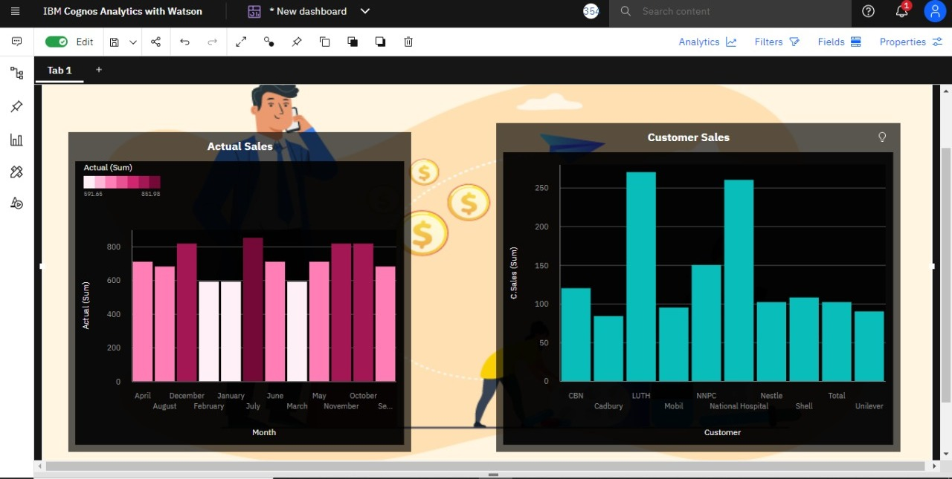

1. SALES BY LOCATION:

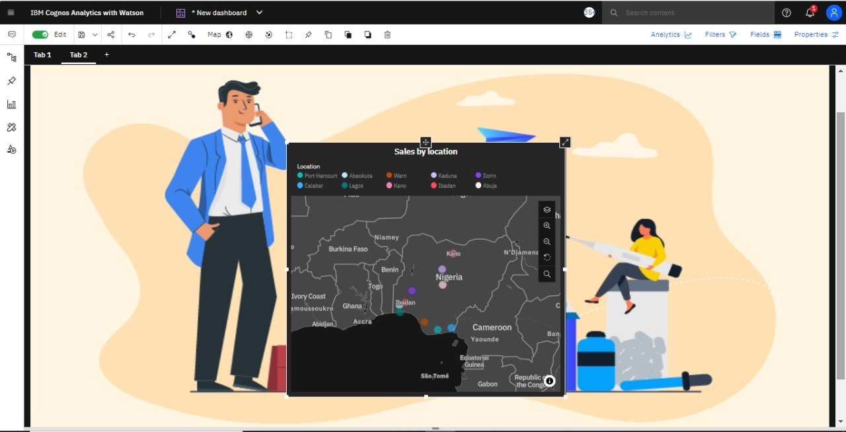

1. SALES BY SALES REPRESENTATIVE:

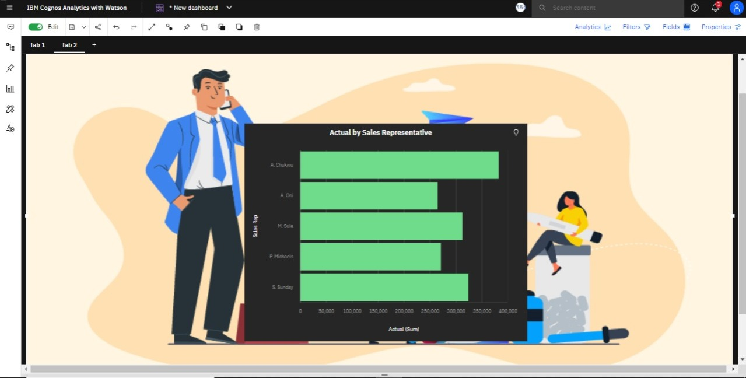

1. RECEIVED INVENTORY FROM SUPPLIER:

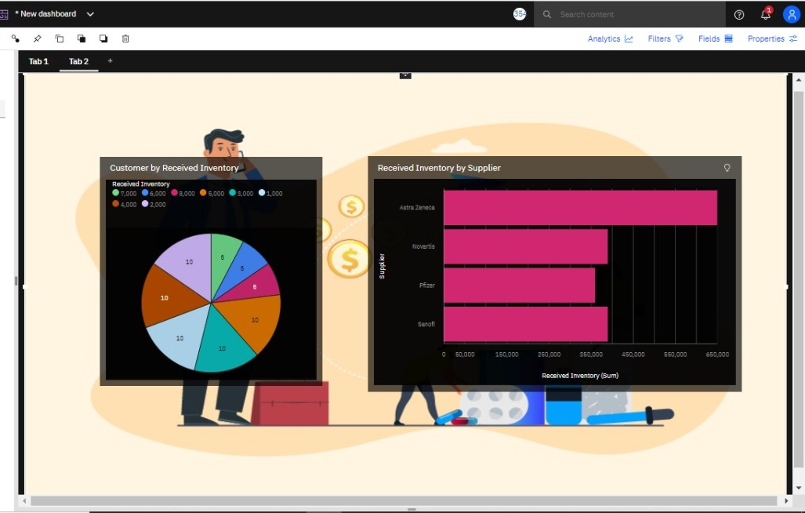

1. INVENTORY STOCK FOR WAREHOUSE LOCATIONS:

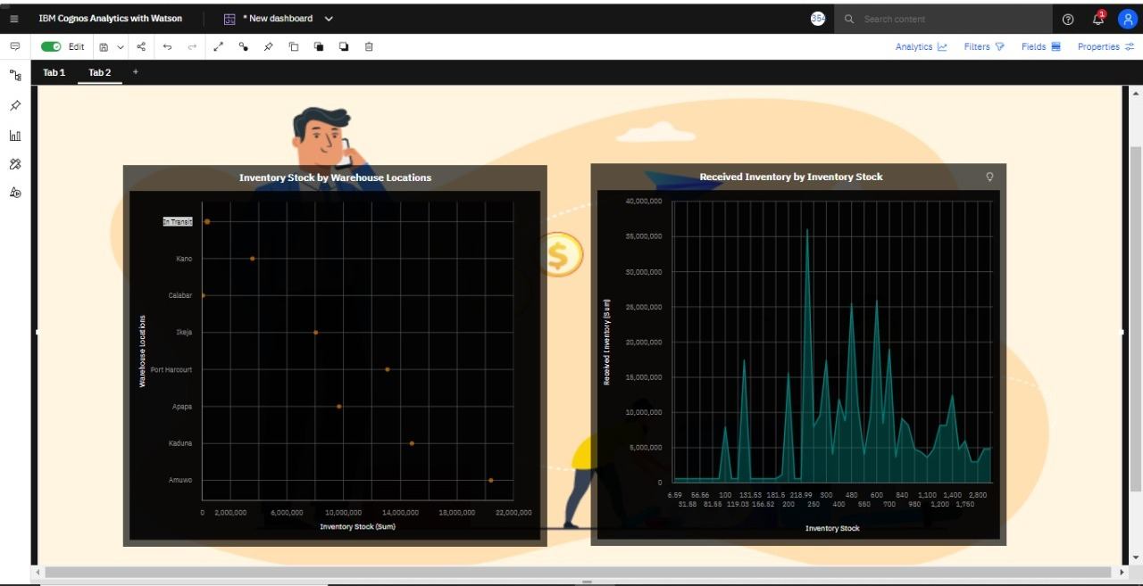

1. SALES TREND:

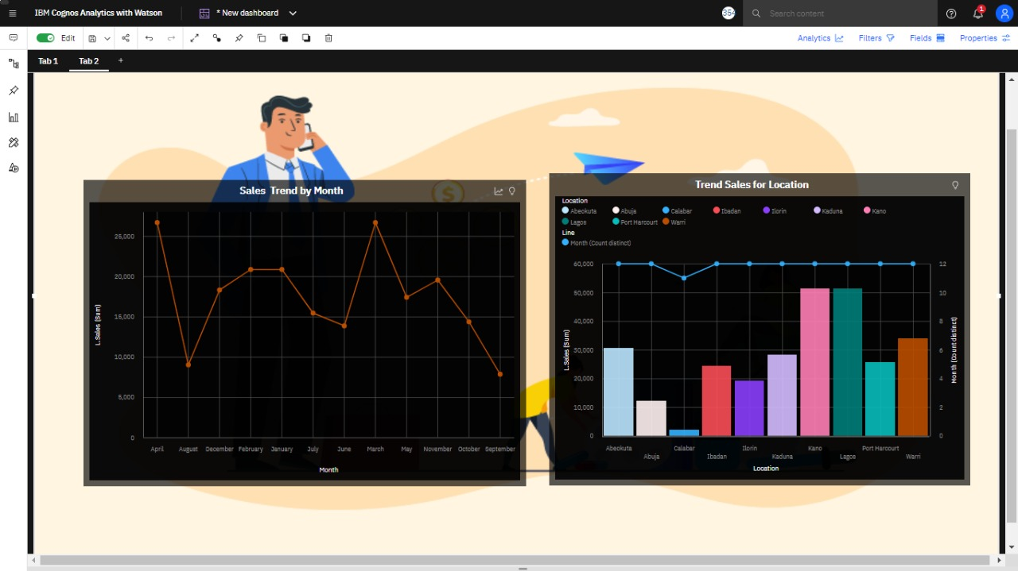

1. MONTHLY SALES:

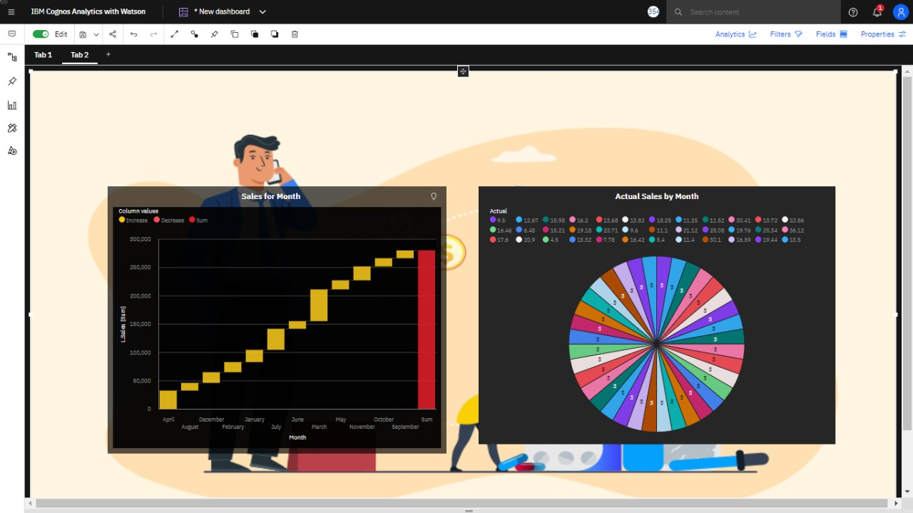

1. ACTUAL AND RECEIVED INVENTORY BY MONTH:

